**Primer Design**

1. **Guidelines for primer design**

For qPCR, **max** amplicon size ~400bp, **ideally 100 - 150bp** (smaller amplicon’s give more consistent results because PCR is more efficient but do not go to small as it can lead to a build up of small product contaminants)

|  |  |
| --- | --- |
| **Primers (qPCR – but also useful for normal PCR primers)**   * **18-24 nucleotides in length** * G/C content **40-60%** * Balanced distribution of G/C and A/T * 2 Primers with equal G/C percentage * **3’ region of the primer most important- free from secondary structure, repetitive sequence, palindromes and highly degenerate sequence.** * Sequence of two primers not complimentary to each other (check with idtdna.com, see below) * Primers should have a similar Tm (55-65; if running an assay at 60 °C primers roughly 57-60 °C usually give good specificity/sensitivity) * *NB keep primers within ~1 degree of each other * Total number of G or C should **not** be **more than 3 in the last 5 bases.** * GC clamp at 3’ end useful * **\*Reverse complement the reverse primer before ordering** | **Probes (Taqman)**   * Not complimentary to primers * **Tm of probe should be higher than primers** (ideally 5 degrees or more, for example if primers are 58°C then probe Tm up to 65°C) * Try to have **probe longer than primers** in length up to 30 bases * 5’ end of probe cannot contain a G- This quenches fluorescence * If only one bp difference in probe keep it to centre of probe * A/C mismatch usually gives highest delta Tm * No runs of identical nt, especially G’s (no more than 3) |

1. **Where to start:**

Get DNA sequence for gene/intergenic region of interest (eg off NCBI).

Copy and paste into a word document. Once you are familiar with designing primers you may be able to choose regions of 8 – 24 bp that look good for a primer yourself, but to start with it’s a good idea to use a tool to help identify these regions.

1. **PrimerQuest Tool**
2. Go to IDT’s online (free!) primerquest tool:

<https://eu.idtdna.com/PrimerQuest/Home/Index>

1. Make an account (just need email and password) otherwise it’s not easy to export your results. Then sign in.
2. Copy and paste your sequence of interest in to the search box at the top, then under the section ‘Choose your design’ click on the appropriate box (for Taqman qPCR select the ‘2 primers + probe’ option) and then programme will run.
3. By default, it will give you 5 potential sets of primer (+probe if qPCR). If you want to change settings click on ‘**Customise Assay Design’**
4. If you want more that 5 potential primer sets (especially if gene is big), then under the first option - ‘Results to Return’ – change from 5 to what you want.
5. Under ‘Reaction Conditions’ you can change these if your default PCR/qPCR recipe is different to what they have listed. This will mainly make a difference to the Tm estimations.
6. Here you can also change the optimal GC% and Tm of your primers and/or probe as well as the ideal length of your amplicon.
7. 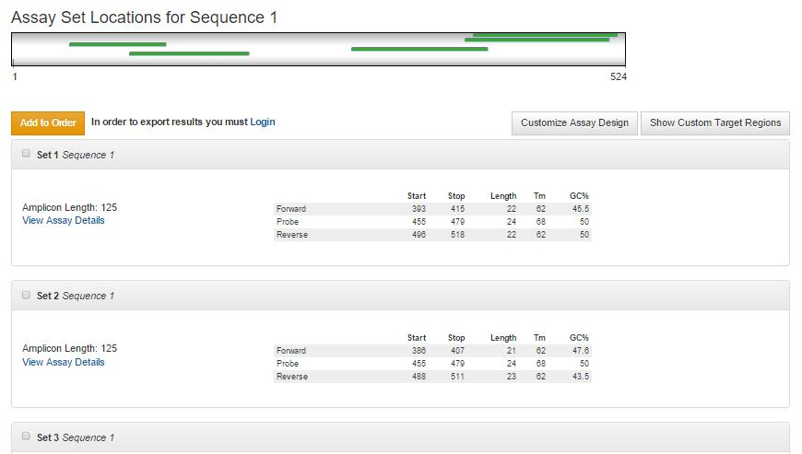Click ‘get assays’ once you’ve made your changes and it will return a page like this:

Click on ‘View Assay Details’ to view sequence of primers and/or primers for first suggested assay set. The following page will appear:

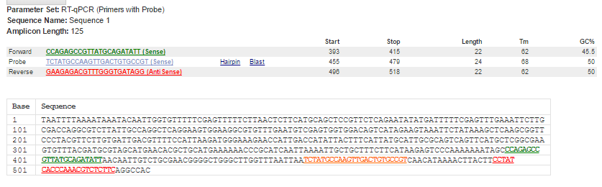

As you can see, up at the top where primers are listed, the reverse primer has been converted to the reverse complement. This is the form in which it must be ordered and therefore in which we check for secondary structure. It also shows the sequence in which the primers and probe are -> if you are designing primers to be specific for a sequence, eg for detection, then you should copy and paste this in ncbi blast to check your sequence is unique. The primers should also be blasted to check for this.

The easiest way to get your hands on the primer sequences to check for complementarity is to download the assays. On the page listing all the assay sets, click the button ‘download assays’ and excel sheet will download. Open this.

1. **Checking the suggested primers and probes for secondary structure etc.**
2. The next step is to check that primers are not too complimentary to themselves/each other/the probe. PrimerQuest doesn’t do this and it is essential this is checked. We are particularly concerned with secondary structure at 3’ end of primers and probes. We use the Oligo analyser tool from IDT to check this. Go to:

<http://eu.idtdna.com/calc/analyzer>

1. Go your excel sheet, and for assay set 1, copy the forward primer and paste into search box. Can change PCR reaction conditions on the right if you want, or just leave as default. Then click ‘Analyse’ (top right orange button) -> this will give you GC%, Tm etc. If PCR reaction conditions are different to that you input in PrimerQuest then Tm may be slightly different, but don’t worry too much about this.
2. Then click ‘Hairpin’ and once results are loaded, scroll down and check the ΔG of ‘structure name 1’ (usually has lowest). In general a 3' end hairpin with a ΔG of -2 kcal/mol or more (more positive I mean), and an internal hairpin with a ΔG of -3 kcal/mol or more is tolerated generally.

***What does ΔG mean???*** *This signifies the amount of energy it takes to break the bonds formed in the structure shown (and make it an unfolded/unbound primer).* ***The more negative the delta G value is, the more energy is required to break this****. So a* **ΔG of -8 is worse than -7 and** *if you have a positive* ΔG *then no worries!*

1. I normally record these ΔG values in the excel sheet downloaded from primerquest. That way, I can go through all primer sets and at the end choose the best ones, as often it is a compromise from the ‘ideal’ primer design conditions.
2. 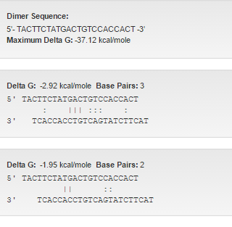If you are happy with this, then check the self-dimer (ie F primer to F primer binding) by clicking ‘Self-Dimer’

The most stable primer-dimer will be shown first

**Check the ΔG**: in an ideal world this should be no smaller than

-5, but it depends on where it is:

* A 3' end self dimer with a ΔG of -5 kcal/mol or more is OK
* An internal self dimer with a ΔG of -6 kcal/mol or more is OK

So in our example the delta G is -2.92 is pretty good so we can carry on to next step.

1. Check F primer to R primer complementarity

Click on ‘Hetero-dimer’ then is search box that appears at bottom of page, paste in the Reverse primer sequence from excel sheet -> it will already be in correct Rev. comp form so don’t click ‘create complement’ , just ‘analyse’

1. 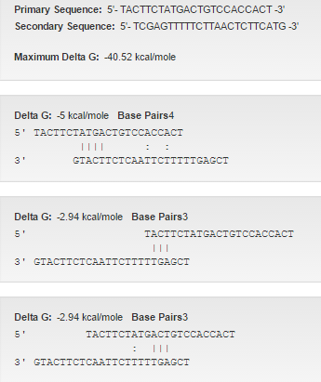Again check top result first. The same rules apply re delta G. So in this example, there is a delta G of -5 at my 3’ end. As it is mostly made up of A-Ts, and I don’t have much choice in the potential numbers of primers (as sequence in short) I will accept this. But if you have a choice, maybe you’ll drop this set and start analysing the next primer set.
2. If designing for qPCR, next analyse hetero-dimer with probe, in same way.
3. Then do same for reverse primer and for probe so that for every assay design set you analyse:
4. **Forward primer hairpin**
5. **Forward primer-forward primer dimer**
6. **Forward primer-reverse primer dimer**
7. **Forward primer-probe dimer**
8. **Reverse primer hairpin**
9. **Reverse primer-reverse primer dimer**
10. **Reverse primer-probe dime**
11. **Probe hairpin**
12. **Probe-probe dimer**

If all of these are within acceptable limits of ΔG, then you can order and try these sets.